1. Product Overview
WIN-SN-CO2-M is a compact, high-precision Carbon Dioxide sensor designed for applications requiring low power consumption and small form factors. It ensures reliable measurements over a wide range. Its RS485 communication interface simplifies integration into small, embedded systems, making it ideal for IOT, HVAC. The sensor's long-term stability ensures consistent performance in harsh environments, making it a cost-effective solution for long-term deployment.
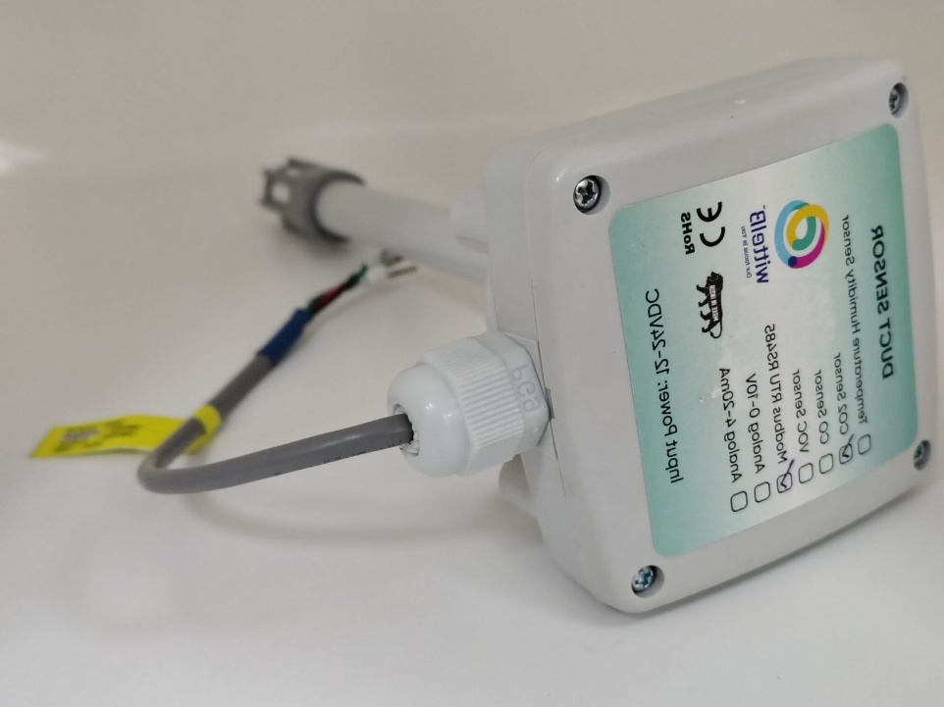

Fig.1 - Product Image

• Carbon Dioxide sensor ranging 400 PPM to 2000/5000 PPM.
• Superior sensor performance.
• Operating range -10°C to 60°C for temperature and 0% to 80% RH for humidity
• Fully calibrated and processed digital output, RS485 Output
• Wide voltage support 12V to 24V DC
• Excellent long-term stability

Sensor specification
 | Measuring Parameter | Measuring Range | Accuracy
☐ | Carbon Dioxide Measurement Range | 400 – 2000 PPM | ±50.0 ppm ±5.0 %m.v.
☐ | Carbon Dioxide Measurement Range | 400 – 5000 PPM | ±50.0 ppm ±5.0 %m.v.

2. Sensor Specifications
- Wide temperature range: −40 °C to +125 °C
- Full humidity range: 0 % to 100 % RH
- Power supply DC: 12-24V@1A.
- Product dimension: 100*100*60 mm.

- Certifications:

3. Power Supply Connection
DC Connection
- Use 12-24V@ 1A, Power supply.
- Don’t make loose connection.

4. Configuration Settings
- Communication Speed 9600 – 115200 Kbps (SW Selectable)
- Data Bits 8
- Parity None
- CRC Yes
- Slave ID 1, DIP (SW Selectable)
- Function Code 0X03 (Read Holding Register)

Recommended Cable Electrical Characteristics
22 AWG Cable Shielded and twisted pair should be used.
Tinned Copper Recommended
Nominal Conductor DCR 14.7 ohm / 1000 ft
Nominal Capacitance 11 pf / feet (conductor to conductor)
High Frequency Non-Insertion Loss 0.5db / 100ft

6. Modbus RS485 Data Storage register
ID | Function  Description | Register  Description | Modbus Function Code | Protocol | Data  Type
1 | CO2 Values | 40001 | 0x03 | RS485 | 16-bit int
2 | Display Baud Rate (Default: 960) | 40011 | 0x03 | RS485 | 16-bit int
3 | Enter New Baud Rate | 40012 | 0x03 | RS485 | 16-bit int
4 | Display Slave ID (Default: 1) | 40013 | 0x03 | RS485 | 16-bit int
5 | Enter New Slave ID | 40014 | 0x03 | RS485 | 16-bit int
6 | Display Parity (Default: None-3 And for Odd-1, Even-2) | 40015 | 0x03 | RS485 | 16-bit int
7 | Enter New Parity | 40016 | 0x03 | RS485 | 16-bit int
8 | Display Stop Bit (start-2/stop bit-1) | 40017 | 0x03 | RS485 | 16-bit int
9 | Enter New Start/ Stop Bit | 40018 | 0x03 | RS485 | 16-bit int

7. Modbus Configuration
Here is an example of receiving data on Mb poll software.
- Open Mb-poll software connect using configuration setting (Default baud rate is 9600 and slave id is 1).
- After connecting you will get data as shown below.
Important Note
- If you want to enter the baud rate 9600/19200/38400/57600/115200etc, enter it like this 960/1920/3840/5760/11520etc.
- After that press the reset button or reboot the system.
- Then you will get the present value of 11520 at 40011 baud rate (115200) and 2 at 40013 slave id.
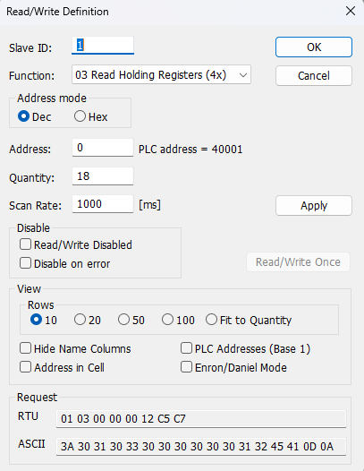
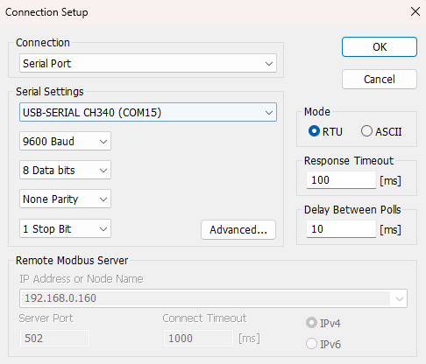

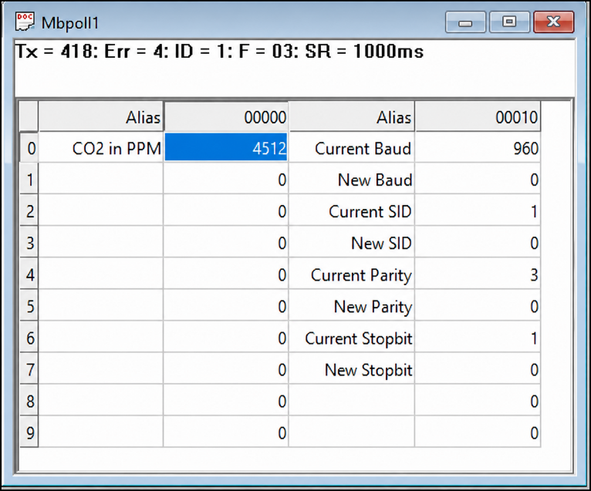
- Above image Shows sensor data over Modbus with default Modbus settings
- At the register 40001 shows CO2 Values.
- As you can see in the image above, the resistor 40011 – 960 represents the present bund rate (9600) of the board and 40013 – 1 represents the present slave id of the board.
- To change the baud rate and slave id Jumper should be in single/removed then, you must enter a value on the 40012 resistors for the baud rate and 40014 for the slave id as shown in the image below and restart the board.
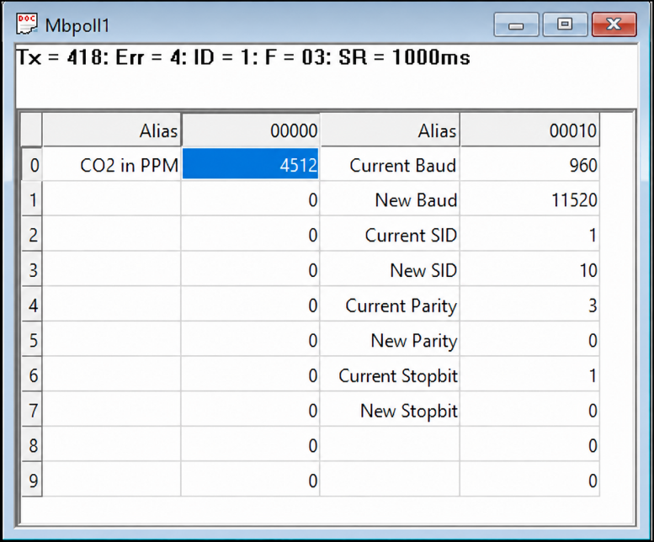
- Now you can see data below image set 115200 baud rate and slave ID 10.
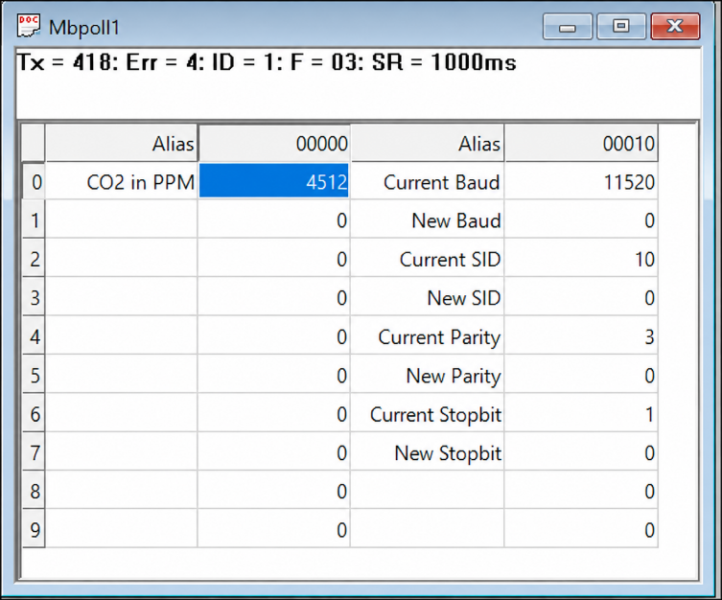

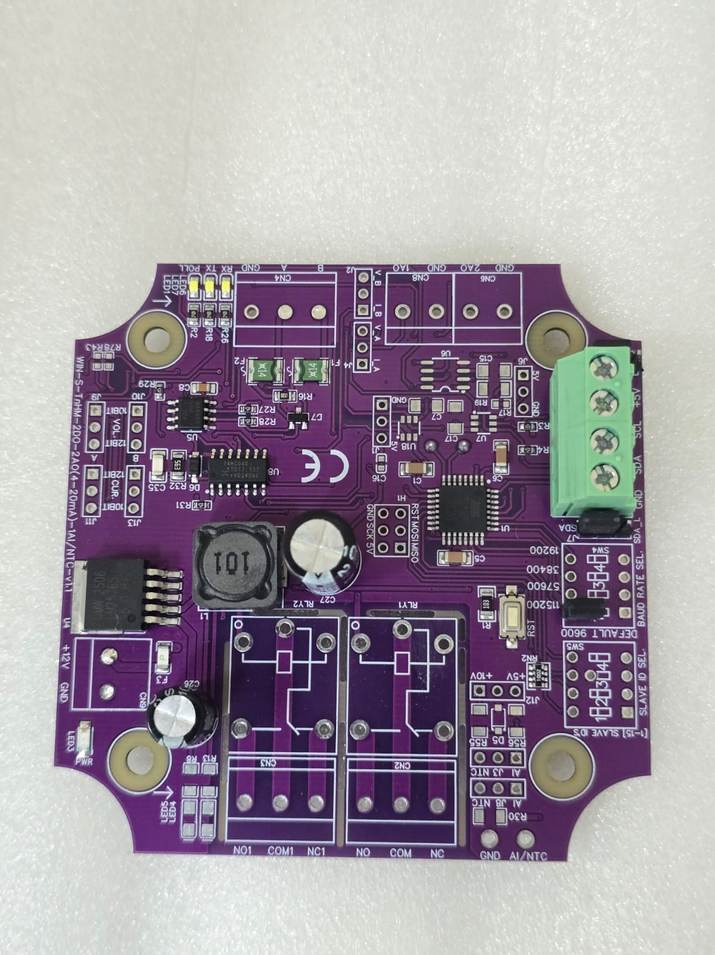
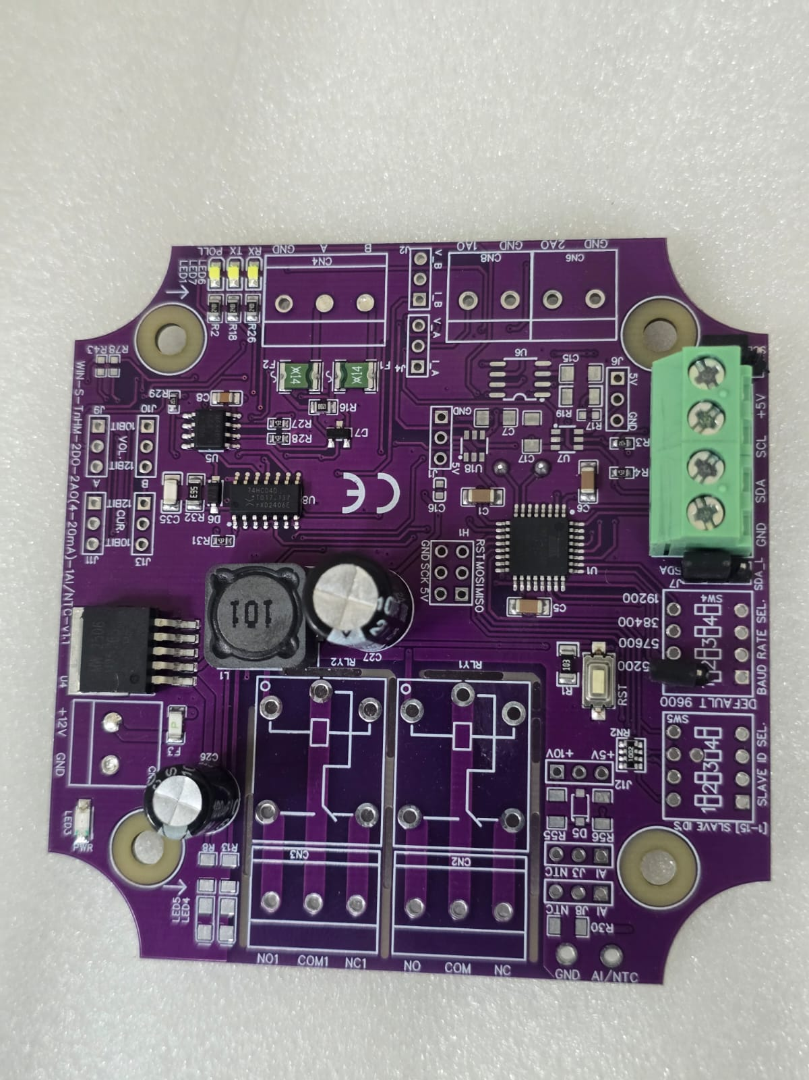

Closed
Open/Remove

Image1.1 Image1.2

Hard reset Setting
- Somehow you forgot the baud rate or slave id of the board then Place the jumper (as shown in the image 1.2) from the board reboot the system or press the reset button (given on the board). Then you will get the default baud rate of 9600 and slave id 1.

Contact Information
Augmatic Technologies Pvt. Ltd.,
Plot no 6, Shah Industrial Estate II,
Kotambi,
Vadodara – 391510.
Email – Sales@wittelb.com
Support: support@wittelb.raiseaticket.com / +91 94038 92805

